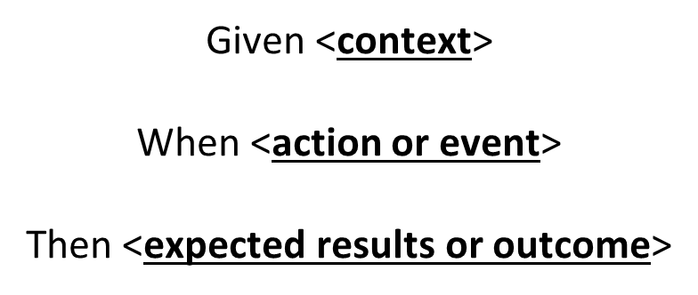

Acceptance Tests:

Given I am an anonymous user,

When I purchase one or more items,

Then I must input my email address.

Given I am a registered user,

When I login correctly,

Then I must be able to purchase items

Given I am not a registered user,

When I attempt a login incorrectly,

Then I receive a ‘failed login’ notice

Given I am a user,

When I purchase one or more items,

Then I must login

Given I am an administrator,

When I change the website,

Then I expect the website to change for everyone